**South Milwaukee United Methodist church**

1327 Marshall Ave, South Milwaukee, WI 53172

umcsm.org

­****

## *The Chimes*

## *July & August 2017*

***How Am I Doing?***

Every year, at some point, I ask myself: how am I doing as the pastor of the church. SPRC evaluates my performance every year and reports it to the district office so that it will be brought to the attention of the bishop and his cabinet. A pastor is accountable to the church, to the Conference and above all, to the Lord who called and appointed him/her to be his minister.

Even Jesus wanted to know how he was performing; he has asked his disciples: “who do people say the Son of Man is?” Then immediately following their response he said, “But what about you, who do you say I am?” (Matt. 16:13-15). He wanted to know how effective he was in fulfilling the task that was given to him by his Father in heaven and in communicating that to his followers.

Likewise, Jesus also likes to see reports from his church and his followers about their performance; he wants us to give an account of our faith. “Always be prepared to give an answer to everyone who asks you to give the reason for the hope that you have. But do this with gentleness and respect, keeping a clear conscience” (1 Peter 3:15).

In order to help us self-evaluate our church-life there is no other chapter in the bible so direct and clear as the second and third chapters of Revelations, where Jesus shows how he likes his church perform in its faith journey. Although these messages applied to the experiences of the specific churches they were written to, they are also prophetic of the experiences of the Church through the centuries. John is told, "Write the things which thou hast seen, and the things which are, and the things which shall be hereafter" (Rev. 1:19).  God willing, I will be discussing these seven different models of churches in my preaching starting from first Sunday in July.

The message for the first Sunday will be about how the first love gradually grows cold. That could reveal the picture of our country, our church or personal life. We may think it is the new normal not to have any spiritual life since that is how the modern culture is! That is why some people have excuses for not being involved in church life. We are right according to the majority around us, but certainly not in the eyes of Jesus. Paul says: “Do not confirm to the pattern of this world, but be transformed by the renewing of your mind. Then you will be able to test and approve what God’s will is, his good, pleasing and perfect will” (Romans 12:2).

Please think of other people around us in the community and pray for their spiritual life. There is an opportunity to invite children of our neighborhood to the VBS, which will be held at the end of this month. Continue to stay in faith,

Blessings,

Harsha

**EDUCATION WORK AREA**

**Vacation Bible School**

**Sunday, July 23rd – Thursday, July 27th from 5:00 PM – 7:45 PM.**

**“Passport to Peru”**

**Everyone is welcome to attend!**

**Invite your friends and neighbors**

**to a fun-filled week! We are in need of food and volunteers, there will be a sign up sheet with the needed items soon.**

***Culver’s Fund Raisers***

Culver’s will donate 10% of sale proceeds to SMUMC with presentation of a voucher. Dates will be July 18th, Sept 19th, Feb 20th and April 17th.

**AWANA Sunday School will resume September 10th.**

**~ ~ ~ ~ ~ ~**

C:\Program Files (x86)\Microsoft Office\MEDIA\CAGCAT10\j0222015.wmf

**June Finance Report**

1. Budget Avg for the month **$14,925.25**
2. Received Avg Monthly- **$13,509.46**
3. Avg Monthly Conf Apportionments **$2,114**
4. Average monthly Apportionments Rec.

**$1,231.90**

1. Individual members Conf Appt part is **$127**

**St. Teresa of Avila wrote:**

Christ has no body but yours;

No-hands, no feet on earth but yours.

Yours are the eyes with which he looks

compassion on this world.

Yours are the feet with which he walks to do good.

Yours are the hands with which he blesses all the world.

Yours are the hands, yours are the feet,

Yours are the eyes, you are his body.

Christ has no body now but yours.

**MISSIONS WORK AREA**

**Next Pancake Breakfast!**

**Save the Date**

**September 17**

**Milwaukee Rescue Mission**

For the months of June thru August we will be collecting back packs for the Milwaukee Rescue Mission, so they will have them when school starts.

**Annual Conference Children’s Kits**

Thanks to your generosity of items and money for the Children’s Kits, we were able to send 24 kits and a bag of rulers and scissors.

**Penny Drive**

$62 was collected during the year toward the Annual Conference Penny Drive. Thanks so much!

**Recipes**

We need your recipes. If you have one you would like to share, please turn it in to the office and we will put it in the Chimes.

**Patriotic Trivia**

As we celebrate America’s birthday, it’s interesting to note that clergymen wrote both the Pledge of Allegiance and the hymn “My Country ‘Tis of Thee”. Rev Francis Bellamy wrote the pledge in 1892. Rev Samuel Francis Smith wrote the hymn in 1831. Both men were Baptist ministers. The pledge was first used in public schools in 1892 during Columbus Day observances. “My Country ‘Tis of Thee” was used as a national song before “The Star Bangled Banner” was named America’s national anthem in 1931.

**Upcoming Date**

A date has been chosen for the upcoming Hobo Dinner. October 7th.

**Scripture Readings for July, 2017**

**July 2**

Genesis 22:1-14

Psalm 13

Romans 6:12-23

Matthew 10:40-42

**July 9**

Genesis 24:34-38, 42-49, 58-67

Psalm 45:10-17

Romans 7: 15-25a

Matthew 11:16-19, 25-30

**July 16**

Genesis 25:19-34

Psalm 119:105-112

Romans 8:1-11

Matthew 13:1-9, 18-25

**July 23**

Genesis 28:10-19a

Psalm 139:1-12, 23-24

Romans 8:12-25

Matthew 13:24-30, 36-43

**July 30**

Genesis 29:15-28

Psalm 105:1-11, 45b

Romans 8:26-39

Matthew 13:31-33, 44-52

**Dates to Remember**

Canada Day, July 1, 2017

U.S. Independence Day, July 4, 2017

**Interfaith Request**

*Can you drive an older adult to a medical appointment once a month? Yes, only once a month! Interfaith Older Adult Programs South Shore Regional Office is looking for individuals to take one transport each calendar month. We would call you a week in advance with the driving details and you always have a choice of saying yes or no. All we ask is that you say yes once each calendar month. If interested, please call Vicki Jensen, Interfaith SSR Volunteer Coordinator, at 414.762.1998 or email at*[*vjensen@interfaithmilw.org*](mailto:vjensen@interfaithmilw.org)*.*

**Scripture Readings for August. 2017**

**August 6**

Genesis 32:22-31

Psalm 17:1-7, 15

Romans 9:1-5

Matthew 14:13-21

**August 13**

Genesis 37:1-4, 12-28

Psalm 105:1-6, 16-22, 45b

Romans 10:5-15

Matthew 14:22-36

**August 20**

Genesis 45:1-15

Psalm 133

Romans 11:1-2a. 29-32

Matthew 15(10-20) 21-28

**August 27**

Exodus 1:8-2:10

Psalm 124

Romans 12:1-8

Matthew 16:13-20

**Thank You**

Charles and Norma Schmidt would like to thank everyone who helped out throwing her a 100th birthday party. And to all those who stopped by and celebrated with her. As Charles put it, “Everything worked out well. Norma was as thrilled as a 100 year old person could be.”



**Our Sympathy**

To the Family of Kathie Kimmel who passed away on June 24th. Her service was held on June 29th at South Shore Chapel. Our prayers go out to her family.

**WILLS & ESTATESCOMMITTEE**

SUMMER IS ALWAYS AN ENJOYABLE TIME OF THE YEAR. THE VACATION PLANS ARE FINALLY PUT INTO MOTION. WHILE THERE ARE PLENTY OF THINGS TO DO AND EVENTS TO ENJOY THIS SUMMER, DON’T FORGET TO KEEP OUR CHURCH IN YOUR MIND. WHEN YOU ARE MAKING PLANS TO ENJOY THE SUMMER, PLEASE CONSIDER MAKING PLANS TO SUPPORT OUR CHURCH THROUGHOUT THE SUMMER TOO. OUR CHURCH NEEDS YOUR HELP AND SUPPORT ALL YEAR LONG.

IF YOU HAVE CONSIDERD MAKING A BEQEST TO OUR CHURCH, DON’T FORGET THAT THE WISCONSIN UNITED METHODIST FOUNDATION IS HERE YEAR-ROUND TO HELP COMPLETE THE ARRANGEMENTS THAT ARE NEEDED TO DO THAT.

THE FOUNDATION IS LOCATED IN SUN PRAIRIE, WISCONSIN. THE STAFF AT THE FOUNDATION HAS THE KNOWLEDGE AND RESOURCES YOU NEED TO ARRANGE A GIFT TO OUR CHURCH BOTH NOW OR FOLLOWING YOUR DEATH. PLEASE CALL THE CHURCH OFFICE AT 762-6030 OR THE FOUNDATION AT (TOLL FREE) 1-888-903-9863 FOR MORE INFORMATION.

THANK YOU.

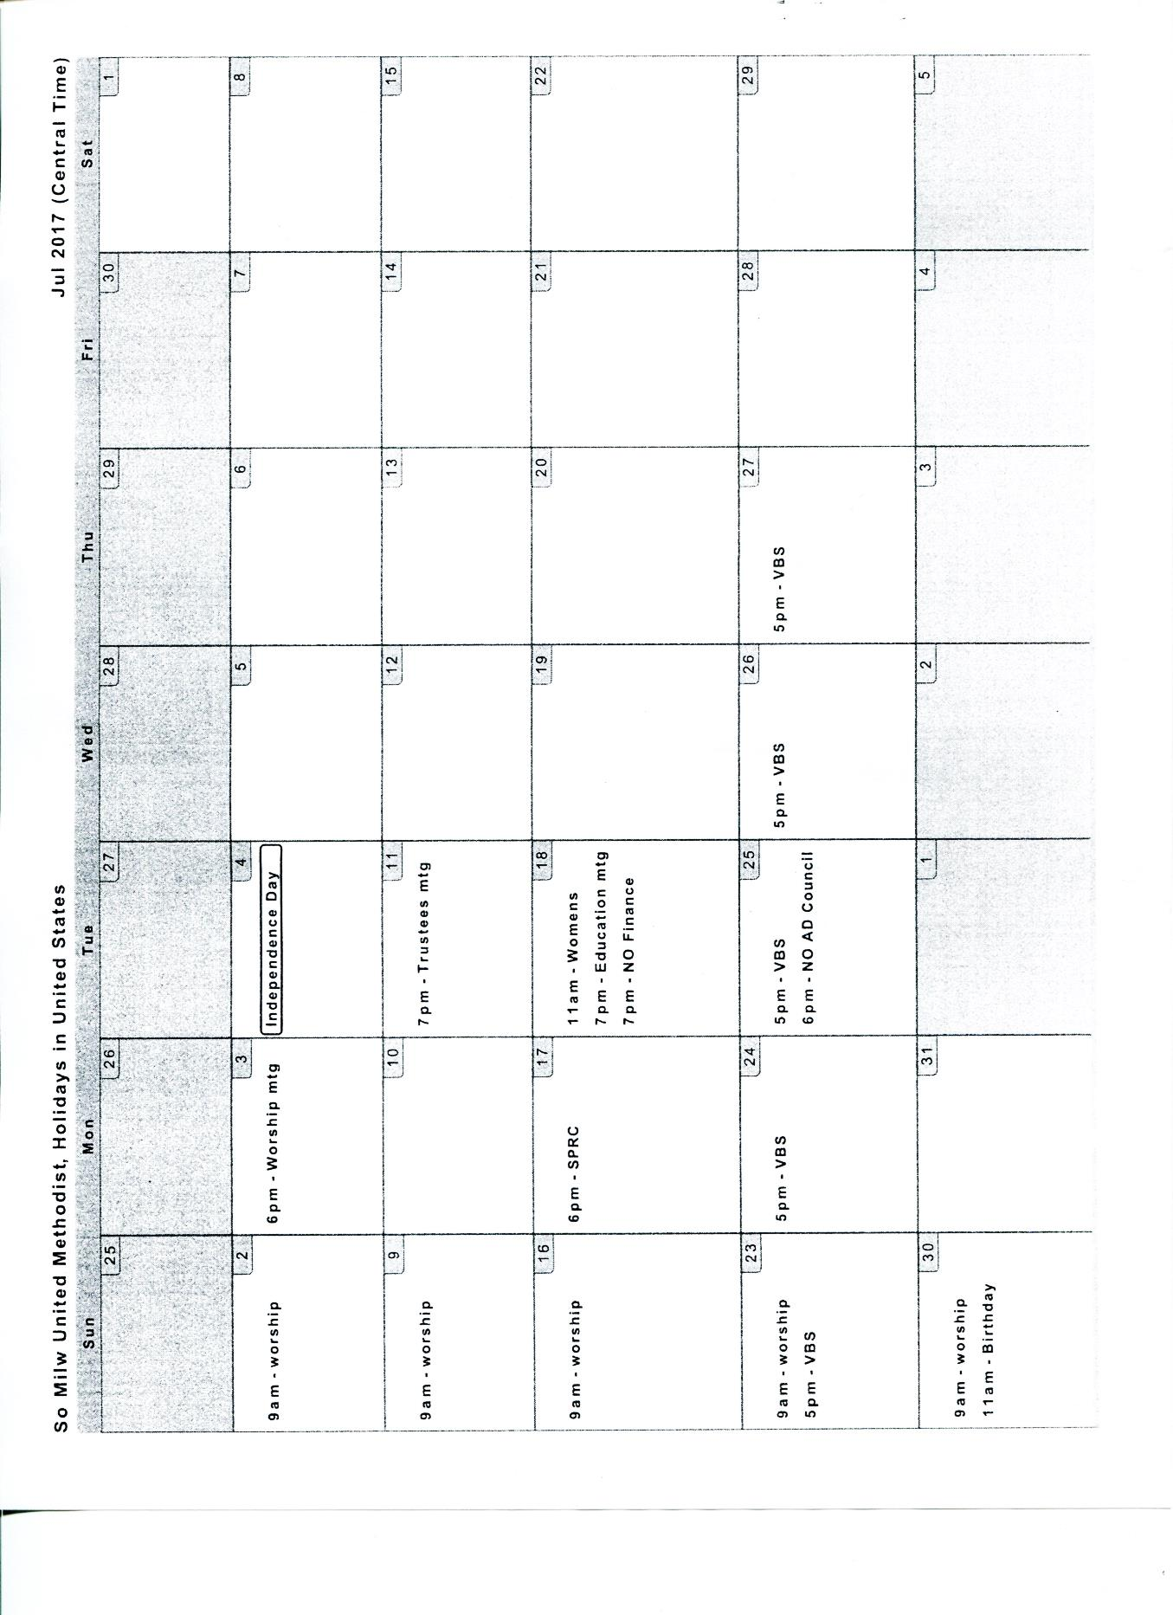MIKE JANKOWSKI

WILLS & ESTATES COMMITTEE

