**South Milwaukee United Methodist church**

1327 Marshall Ave, South Milwaukee, WI 53172

umcsm.org

­****

## *The Chimes*

## *March, April 2018*

Friends,

How is your observing of Lent refreshing your soul and reconnecting you to the divine? The Lent is a time of reflecting, soul-searching, disciplining and renewing of souls in the presence of the cross of Jesus. That makes us sing: “What wondrous love is this that cause the Lord of bliss to bear the dreadful curse for my soul.” Grasping the meaning and power of the cross eventually lead us to dive into the joy of Easter that explodes in our singing: “Up from the grave he arose, with a mighty triumph on his foes; he arose a victor from the dark domain, and he lives forever with his saints to reign. He arose, he arose, hallelujah! Christ arose!”

The season of Lent and Easter comes and goes as usual every year. So what is the big deal about them? Certainly there won’t be any big deal until we step up to taste the joy and power of the Lent and Easter. To make the joy and the beauty of Easter ours as never had before, we just need to consider the example of Jesus.

Think about the words from Hebrews 12:1-2:

“Therefore, since we are surrounded by so great a cloud of witnesses, let us also lay aside every weight and the sin that clings us so closely, and let us run with perseverance the race that is set before us, looking to Jesus the pioneer and perfecter of our faith, *who for the joy that is set before him* endured the cross, disregarding its shame, and has taken his seat at the right hand of the throne of God.”

Here is a pattern for our Lenten journey that takes us all the way to the joy and victory. If you have lived a meaningful Lent, you will certainly have a life-time joy of Easter. So think of these steps from the above quotation.

- Let us lay aside, - run with perseverance. – looking to Jesus, - the joy that is set before, - disregarding the shame, - the honor beyond imagination…

I want to challenge you to think of Jesus, the death and the Resurrection, not from a historical perspective, not from a scientific perspective, not even from a church history perspective. Please, get your Bible out and think through what happened from a Biblical perspective!

I am personally challenging every one of us to read John chapter 18-20, from now on until the Easter (April 1st). When you read these three chapters, try to put aside everything you have learned about the text and simply take the story into yourself, get down to the heart of the story as you never did before, the story of God’s deep love for you and me!

Possibly read it again and again until you get inside the story and the story gets inside of you. Read it with others or simply read it having Jesus before you. Dive into the story and embrace it for ALL that it is, life changing, life giving, and life transforming and making you a new creation (Rom. 1:16)! I look forward to hearing about your encounters with the Living Word. Happy Lenten meditation, happy Easter! Peace and God’s blessings. In Christ,

Harsha

**EDUCATION WORK AREA**

**Teacher’s still needed**

If you or someone you know is willing to teach Sunday School, just occasionally. Please let

Loree Simuncak know.

*The Education Work Area*

**Culver’s Fundraiser**

There is a upcoming fundraising event, April 17th at Culver’s the corner of Howell and Drexel. Ave. 10% of sales, when our voucher is presented will go to the church. $30 dollars was received from the last fundraiser.

**Upcoming Children’s Performances**

The kids will perform in church on the following Sundays; 3/18, 4/22 and 5/20.



**Bowling Outing**

We had a great time bowling at JB’s on 41. Watch for pictures from this event.



**Easter Egg Hunt**

Will be held on Easter Sunday, April 1st after the church service.

**Save The Date**

VBS will be held on July 22-26th, 2018



**Easter Cantata**

The Choir will be performing their Easter Cantata on Palm Sunday, March 25th at 9:00 AM. Please come and hear the beautiful voices sing out.

**MISSIONS WORK AREA**

**From the Winter Wear Tree**

At the end of January we sent 49 caps, 20 cap and scarf sets, 11 scarves, 20 pair of gloves and mittens, 1 fleece throw, and 1 work jacket. Your generosity is overwhelming.

Thank you so very much!

**Milwaukee Rescue Mission**

We will extend the time to collect for Milw Rescue Mission until March 11th. They are in need of; khaki pants & red and blue polo shirts,(uniform style) sizes 6-10. They also need men’s xxl- 3x sweatshirts, sweaters, or long sleeve shirts.

**March is**

**South Milwaukee Human Concerns.**

Our March Mission Project is Human Concerns. They are in need of food and hygiene items.

**Disaster Response to Texas Hurricane**

Our church responded to the hurricane relief effort by sending $755 in October of 2017. Sorry for the late report!



**Pancake Breakfast**

There will be a Pancake Breakfast on Sunday March 11th with set up on Saturday March 10th. Breakfast is held at 7:30 & 10:00 AM. Costs are; $6 for Adults, $4 children 6-11, and under 5 free.

January Pancake Breakfast netted; $319.

*The Mission Work Area*

|  |
| --- |
|  |
|  |

**Scripture Readingings for March, 2018**

**March 4**

Exodus 20: 1-17

Psalm 19

1 Corinthians 1: 18-25

John 2: 13-22

**March 11**

Numbers 21: 4-9

Psalm 107: 17-22

Ephesians 2: 1-10

John 3: 14-21

**March 18**

Jeremiah 31: 31-34

Psalm 51: 1-12

Hebrews 5: 5-10

John 12: 29-33

**March 25 (Palm Sunday)**

Mark 11: 1-11

Psalm 118: 1-2, 19-29

Isaiah 50: 4-9a

Psalm 31: 9-16

Philippians 2: 5-11

**March 29 (Holy Thursday)**

Exodus 12: 1-4, 11-14

Psalm 116: 1-4, 12-19

1 Corinthians 11: 23-26

John 13: 1-17

**March 30 (Good Friday)**

Isaiah 52: 13-53

Psalm 22

Hebrews 10: 16-25

John 18: 1-19: 42

**Scripture Reading For April**

**April 1 (Easter Sunday)**

Acts 10: 34-43

Psalm 118: 1-2, 14-24

1 Corinthians 15: 1-11

John 20: 1-18

**April 8**

Acts 4: 32-35

Psalm 133

1 John 1: 1-2, 2

John 20: 19-31

**April 15**

Acts 3: 12-19

Psalm 4

1 John 3: 1-7

Luke 24: 36b-49

**Missionary Paul Webster**

**“Every Day, I See God at Work”**

When United Methodist missionary Paul Webster arrived in northwest Zambia in 2000, he immediately became aware that the people of one of area’s tribes-the Lunda- were exhibiting signs of extreme protein deficiency. Game in the area had been completely hunted out, and there was no predictable food source. The Lunda people had the lowest life expectancy rate and the highest mortality rate in the country. In other words, people were literally starving to death. Around that same time, the local chief of the Lunda people gifted the Zambia Conference 2,500 acres of lawhich included a river and a waterfall. So Webster set about propogating high-protein foods, starting with soybeans and eggs. Now 17 years later, that land is referred to as Mujila Falls Agricultural Center. It’s still run by Webster, and it has created a robust local economy that only feed local people but provides them with business opportunities and income. “Every day, I see God at work,” said Webster.

**Dates to Remember - March**

World Day Of Prayer, March 2, 2018

Third Sunday in Lent, March 4, 2018

Pancake Breakfast, March 11, 2018

Fourth Sunday in Lent, March 11, 2018

Daylight Savings Time begins, March 11, 2018 Fifth Sunday in Lent, March 18, 2018

First Day of Spring, March 20, 2018

Palm/Passion Sunday, March 25, 2018

Holy Week, March 25, 2018

Maundy Thursday, March 29, 2018

Good Friday, March 30, 2018

**April**

Easter Sunday, April 1, 2018

Administration Professionals Day,

April 25, 2018

**April 22**

Acts 4: 5-12

Psalm 23

1 John 3: 16-24

John 10: 11-18

**April 29**

Acts 8: 26-40

Pslam 22: 25-31

1 John 4: 7-21

John 15: 1-8

**Wills & Estates Committee**

By now everybody is crossing their fingers that winter will be finished soon. Too much cold and snow must be why they decided to make February the shortest month of the year. But if you like making a snowman, sking, sledding, ice skating, etc it’s been a great month.

The winter season is also a great time to make or to review your plans to support our church both before and after your death. As always, if you would like to make the arrangements to support our church through a gift from your estate, the Wisconsin United Methodist Foundation is the best place to seek the advice and help needed to do just that. Just as there are advantages in doing that while you are alive. There are many advantages in doing that through your estate after your death. The staff at the foundation has the knowledge and resources you need to arrange a gift to our church both now or following your death.

The foundation is located in Sun Prairie, Wisconsin. Please call the church office at 762-6030 or the foundation at (toll free) 1-888-903-9863 for more information. Thank you.

Mike Jankowski

Wills & Estates Committee

C:\Program Files (x86)\Microsoft Office\MEDIA\CAGCAT10\j0222015.wmf

**January & February Finance Report**

1. Budget needs each month **$15,763.33**
2. Received for budget year to 2/28 $**22,610.51**
3. Average monthly conf appt **$2,095.00**
4. Received for conf appt year to 2/28 **$3001.51**
5. Individual member’s conf appt **$156.15**

**Dispelling the darkness**

On Good Friday, many churches hold a Tenebrae worship service. Tenebrae (Latin for “darkness” or “shadow”) is an ancient Christian tradition that recreates the emotions od Jesus’ Passion and death. The sanctuary gradually grows darker. A strepitus (Latin for “loud noise”) may signify the closing of Jesus’ tomb. As the service concludes, a Christ candle stands alone on the altar, reminding worshipers that victory is coming on Easter morning.

When Scottish missionsry Peter Milne died in 1924, the thankful people he’d served in the South Pacific inscribed this message on his headstone; “When he came, there was no light; when he died, there was no darkness.”

Death’s darkness couldn’t conquer Jesus, the light of the world, so it does not conquer us. “The light shines in the darkness, and the darkness has not overcome it”

(John 1:5, ESV)

**C**ivilian **R**esponse to an **A**ctive **S**hooter **E**vent

C,R.A.S.E. Training is a program designed to prepare citizens in the event of an active shooter attack. Although rare, these incidents can happen anywhere at anytime. The SMPD has two certified CRASE instructures on the department. We would like to put on a free training session for those interested. The training would be approximately 1.5 hours long. I was told if we could get 15 to 20 people signed up, or more, they will conduct this training here at church. There is a sign-up sheet out in the narthex, if you are interested in signing up. The date will be determined AFTER WE GET PEOPLE SIGNED UP.

**Dear Friends**

I want to thank you for your generous out pouring you sent to help me celebrate my day! The cards came from a large group of friends and from other people that I don’t know too well. It was an act of kindness that made me feel good, and that someone actually took the time to do!

*“Thank You”* Matt Glaske

***Thank You!***

I wish to thank the people for their kind words & beautiful cards, and the nice tribute from Pastor Harsha and the congregations wishes in song that all contributed to a wonderful 93rd birthday.

***Lucille Gentil***



Easter Lilies

This year we will be offering the Nellie White Lily. The cost will be $11 each. Orders are due to the office by Monday, March 12th.

White Lily

Memory

Of:______________________________________

Or

Celebration

Of______________________________________

Name____________________________________

Flowers are from Custom Grown Greenhouse.

Please pick up your flower after the Easter service.

**Welcome**

We would like to welcome our newest member here at So Milw UMC

Kathie Stenzel

**New Carpet**

Last fall Richard and Karen Timian came for a visit. They were married in the parlor 40 some years ago and Richard’s Scout troop also laid the tile in the entrance and up the ramp. So after their visit, they called and gave our church a gift of new carpet in the parlor. We thank them very much. Stop by and look at our new carpet.



**Memorial Service**

On February 18th a Memorial Service was held at the South Milwaukee United Methodist church for Richard Seney who died on January 21st. Richard was a member of this church for many years. Rev. Harsha Kotain officiated . Our sympathy to his family.



**Do Not Forget Day Light Savings.**

**Spring Ahead 1 hour.**

**March 11th**

**MY CHURCH**

I am having a hard time beginning to explore my feelings about “my” church. It has opened my eyes and made more clear how God shows his love for me. As a young woman, my husband and I began attending this church. Through these 50+ years I have grown more aware of God’s love. Teaching children in Sunday school made it clearer to me that at all are loved deeply. This church has seen me through good and bad times and all the “in-between” times. If I could be in two places at one time, I’d be with you. I am withdrawing my membership to save the financial obligations in keeping me on the records. I will keep you all in my thoughts & prayers. *Nola Gondek*

**CREATION**

Buckminster Fuller wrote a detailed description of Man in great detail using terms a mechanical engineer might use to describe him as a robot:

***“What is Man, that Thou art mindful of him?***

.A self-balancing, 28-jointed adapter-base biped; an electrochemical reduction-plant, integral with segregated stowages of special energy extracts in storage batteries, for subsequent actuation of thousands of hydraulic and pneumatic pumps, with motors attached; 62,000 miles of capillaries; millions of warning signal, railroad and conveyor systems; crushers and cranes (of which the arms are magnificent 23-jointed affairs with self-surfacing and lubricating systems, and a universally distributed telephone system needing no service for 70 years if well managed.”………he describes eyes, mouth and ears. and the brain…..”

Within the few cubic inches housing the turret mechanisms, there is room, also, for two sound-wave and sound-direction-finder recording diaphragms, a filing and instant reference system, and in expertly devised analytical laboratory large enough not only to contain minute records of every last and continual event of up to 70 years' experience, or more, but to extend, by computation on and abstract fabrication, this experience with relative accuracy into all corners of the observed universe. There is, also, a recasting and tactical plotting department for the reduction of future possibilities and probabilities to generally successful specific choice.”……….and his ability to communicate with the world and into space and beyond, summing it up..…””A man, indeed! Dismissed with the appellation "Mr. Jones"!”

And God did all this with a lump of clay!

Also, He gave us a maintenance manual for use and care of this marvelous creation. The Bible tells in great detail how to manage our lives and care for ourselves and others. We treat some of our mechanical and electronic constructs better than we do the one we were given to begin with---- health maintenance, maintaining our relationship with God and fellow human beings. What kind of connections have we maintained with God? Reconnect often (daily is better) with the Bible.

Don’t “wait til all else fails” to read the Nola Gondek 2018 directions.

** **

**It Is That Time Of Year**

**The Spring Rummage Sale**

Saturday, April 28th 2018

Time to get your gently used items in here for our Spring Rummage Sale.

You can put your items in Als’ room. Also, start thinking about helping. We need as many people as we can get to; set-up, sort, organize, sell, pack up, etc…

Be the help, Be the change!

**MARCH 2018**

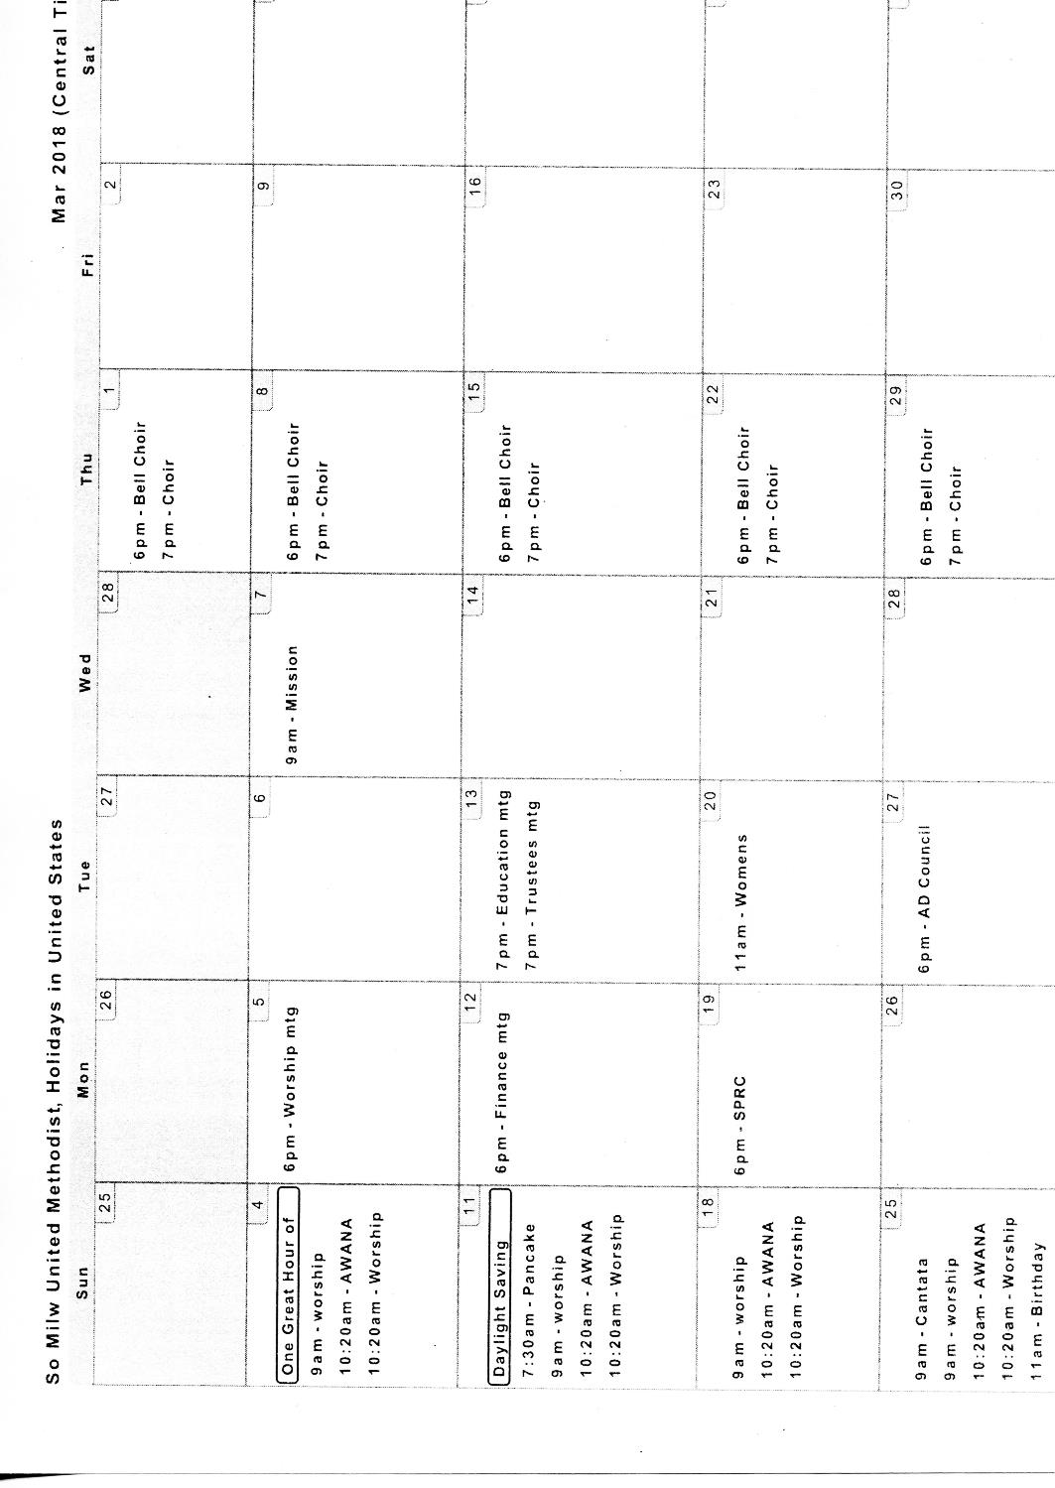

**APRIL 2018**

