**South Milwaukee United Methodist church**

1327 Marshall Ave, South Milwaukee, WI 53172

umcsm.org

­****

## *The Chimes*

## *May, June 2018*

Friends,

*TIME TO SAY GOODBYE*

It is difficult to imagine how quickly the years have flown by that it has been six years since Mavis, Joylin and I stepped into the life of this church. As time went by we all got closer to one another in sharing and celebrating life and God’s blessings, we lost track of how long had our journey been together.

One of the most painful times in ministry is to say goodbye after being part of the church for so long. We have been sharing joys, celebrations, losses, and challenges which made us church together.  I’ve watched children grow up. I’ve baptized, confirmed, performed marriages, and also did too many funerals. I’ve visited hospitals and shut-ins; together we realized a few dreams, lived through a few trials, and persevered. We have brought our gifts and talents, offered them to God, and grown closer to him and to one another in the process.

We have worked side by side, continually exploring our faith and experiencing the marvel of having God in us.  We’ve sought to discover what it means to be a Christian. We’ve gathered in large groups and small to serve others and to discuss how to draw others to know God and his love in Jesus.   We’ve worshipped, sang together, prayed together, served together the needy around us and even wept together with those who were weeping.  I have witnessed God working in our midst, even the miracles happening.

I thank you for the times that you invited me into your homes and to your lives; sharing with me the highs and lows that come with life.  Whether it is welcoming a new baby into our world or paying homage to those who depart, I was there. My heart has been heavy as we have said farewell to many wonderful sojourners who lived and worshipped with us, and no longer with us, yet they remain very much alive in our memories,

True, life is always changing; nothing in life remains the same. But we feel its intensity when meet with situations like this, a change in leadership. But what gives us comfort and hope in the midst of all this is, we have an unchanging God whose love and mercy remains constant: “The steadfast love of the Lord never ceases, his mercies never come to an end; they are new every morning” Lamentations 3:22. Let us praise God, we have such a wonderful God on our side!

Saying good-bye is never easy, but understanding that this transition is God’s will not only for me, but also for the church in South Milwaukee, eases the pain a little.  Your love and kindness have given me the strength and courage to follow God’s will. The best way to celebrate the ministry of a pastor is to thank God for the years spent together and be open to receive a new pastor as God’s gift and his will for the church.

In the last 125 years of its existence, our church has welcomed and said good bye to 36 pastors according to the plaque on the wall by the church library. Interestingly, while about a third of these pastors served two years or less (one year: 9, two years: 5), another third served between five and nine years (5-3, 6-3, 7-1, 8-4, 9-1), among which Jim Harington was the longest serving pastor (nine years) until now. Itinerancy is part of the United Methodist church system which is also its strength and blessing by bringing leaders with varieties of gifts and abilities to church.

When I close my eyes my mind floods with the memories of all these years with you. Without question I can look at my experience with you and realize that this has been a “Spirit-thing,” not a “human-will” or “coincident” that we walked together. I give all glory, honor and praise to God who started this work with us and will finish it without me. I thank God for the privilege of helping you to embrace the most blessed life with God; you have been my “pastor’s dream church” and the church I carried in my heart and prayer.

It pains me deeply to say goodbye to this church I loved; it is not a pleasant thing at all, but I also have peace in my heart knowing that God is going to use me in Ripon, the next church I will be leading, for his Kingdom, and he will continue to use you in the work of his Kingdom under the new leadership!

Remember to love the people around you and strive for unity within the body; stay close to God and be sensitive to his Spirit; pray daily for your pastor Sun Joon Kim, the one God is preparing right now to become your next pastor and your spiritual leader. Never lose sight of evangelism; it is the heart and vitality of Christian life. Finally, remember me and my family and the new opportunity God is providing me in another place. I love you all in Christ and continue to hold you dear to my heart. Though my address may change, my destination is still remains the same–I’ll be waiting for you at the Eastern Gate.

To God Be the Glory!

Blessings,

Harsha

***I WILL MEET YOU IN THE MORNING***

I will meet you in the morning,  
Just inside the Eastern Gate;  
Then be ready, faithful pilgrim,  
Lest with you it be too late.

Refrain:  
I will meet you, I will meet you  
Just inside the Eastern Gate over there;  
I will meet you, I will meet you,  
I will meet you in the morning over there.

If you hasten off to glory,  
Linger near the Eastern Gate,  
For I’m coming in the morning;  
So you’ll not have long to wait.

Keep your lamps all trimmed and burning;  
For the Bridegroom watch and wait;  
He’ll be with us at the meeting  
Just inside the Eastern Gate.

Oh, the joys of that glad meeting  
With the saints who for us wait!  
What a blessed, happy meeting  
Just inside the Eastern Gate!





*TIPS TO WELCOME*

*THE NEW PASTOR*

**Pray For Your New Pastor and Tell Him that You Are Praying**

There is something that is so reassuring to know that other people are specifically praying for you.  This is encouraging for at least 2 reasons.  First, it is so encouraging to know that there is spiritual maturity in this new flock of people in that they are praying for you.  And second, it is nice to know that these new people care and love you enough to pray to God for you.  Both of these reasons will be important to your new pastor.

**Don’t Compare Your New Pastor to the Last Pastor**

Even if you are saying things in a positive way it is not good to be comparing one pastor to another.  Each pastor brings their own set of [spiritual gifts](https://www.whatchristianswanttoknow.com/what-are-gifts-of-the-spirit-a-bible-study/) and abilities that God has given them to this job of shepherding the local church. Embrace that and don’t compare them outwardly as it can bring in some unhealthy expectations.

**Let the pastor set the pace** –

It will take a while for a new pastor to figure out their stride. Give them your understanding during this time. They may not make every visit you want them to make. They may not place priority where you think it needs to be placed. They may not introduce change as fast as you want them to, or it may seem too fast. Let them set the pace – especially in the early days.

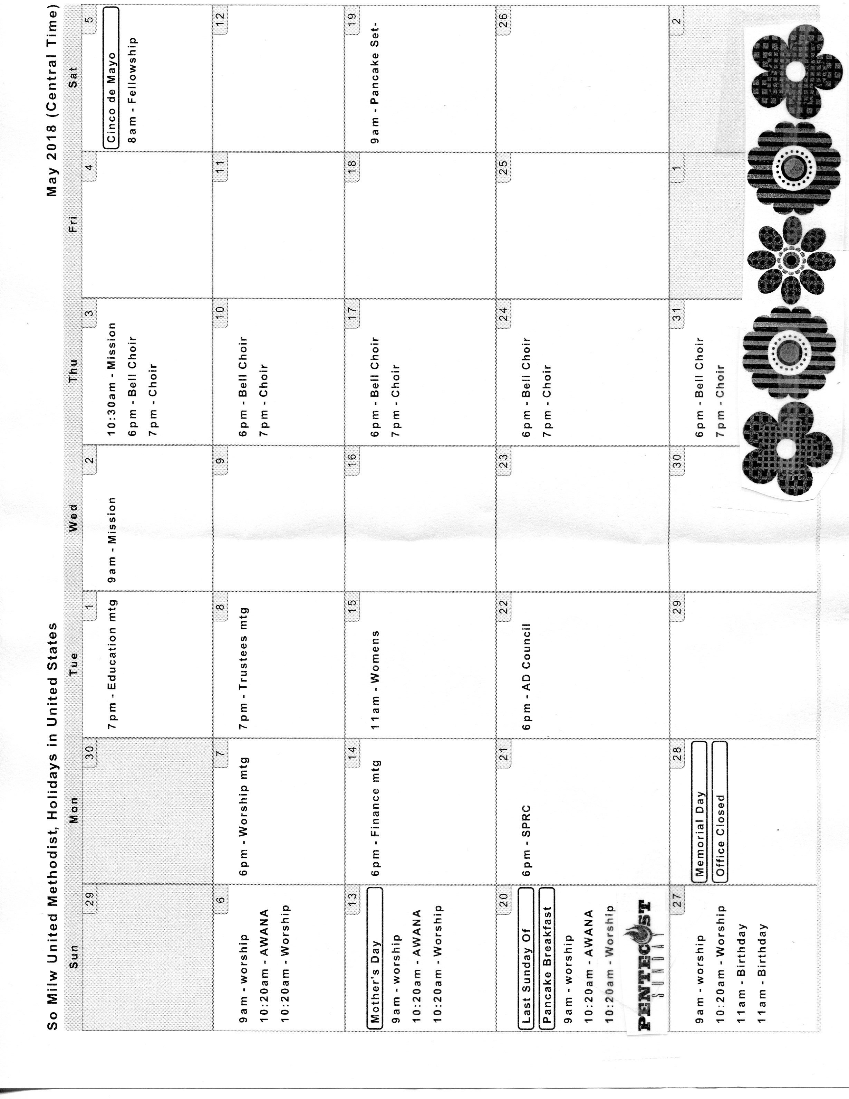

**Tell the pastor Your Name – again** –

and again, and again, if necessary. Learning names may be the hardest thing a new pastor has to do. Give them ample time to learn yours.

**Don’t offer a million suggestions** –

There will be time for that, but the new pastor needs time to learn the church. Most likely you’re already doing lots of things – some good and maybe some not so good. Let them learn who you are as a church before you fill their head with too many new ideas.

**Don’t prejudge** –

A new pastor will make their own mistakes. Don’t hold a previous pastor’s mistakes against them. Don’t assume, based on their history or your expectations of them, that they will perform a certain way. They may. They may not.

**Extend the honeymoon** –

Honestly, it usually seems too short anyway. If the pastor begins to make any changes at all, some people lose faith in them. A new pastor needs time to acclimate. He needs time to learn you and the church. Keep loving and supporting him, even when changes become harder to make and harder to accept. If God brought the pastor to your church, God wants to use them there. Let God do as God intended.

**Let the pastor lead** –

Remember, a pastor is called to lead the congregation; let the pastor know the needs of the congregation and the community. That helps pastor to navigate the ideas and put them in alignment with the vision of the church.

Never invite the former pastor to perform events in the church. The former pastor will refrain from accepting such invitations in order to help the parishioners get acquainted with the new pastor.

-----

**Pastor Harsha’s last day at SMUMC:**

June 30, 2018.

Last Sunday at the church: June 10, 2018

At the Annual Conference: June 15-18

Vacation Sunday: June 23rd

**Pastor Harsha’s new address:**

**Church:**

Immanuel United Methodist Church

401 W. Fond du Lac St

Ripon, WI 54971

Phone: 920-478-6695

**Parsonage:** 17 Wa Wa Ave

Ripon, WI 54971

Phone: 414-676-4675 (C)

----------

**SUMMER CAMPS 2018**

Wisconsin United Methodist Summer Camps 2018

Building community, equipping disciples, and modeling care of creation in ways that reflect the love and grace of God.

*For reservations or more information you can contact*

The website at www.WUMCamps.org

**EDUCATION WORK AREA**

**Teacher’s still needed**

For our Fall/Winter program for the 2018/2019 year. Fall session begins Sept 9th.

*The Education Work Area*

**Culver’s Fundraiser**

We received $35 from the April 17th Culver’s fundraiser. Thank you to all.

**Upcoming Children’s Performances**

The kids will perform in church on the following Sunday; 5/20.

The kids had a great time at the Easter Egg Hunt after the Easter Service. Stay tuned for a mini golf date in August.



**Save The Date**

VBS will be held on July 22-26th, 2018 from

5:00 pm – 7:45 pm. The theme this year is “Shipwrecked-Rescued by Jesus” stay for dinner, games, educational projects, singing and fun!

Please consider bringing your aluminum cans to the church for recycling. Proceeds from your donations benefit our youth.



Please join us for a Senior Recital by Stephen Simuncak Featuring works by Bach, Rachmaninoff, Saint-Saens and Vivaldi.

Sunday June 3rd, 6:00 PM

South Milwaukee United Methodist Church

**MISSIONS WORK AREA**

**Red Bird Mission**

Each year we are able to send a donation around $300 to Red Bird Mission in the Appalachia area of Kentucky. Thanks to your continued support. Here are some of what YOUR contribution can be used for: $30 –Cover Gap Food Pantry food costs for one family visit, $35 – Educate s child for one day at Red Bird Christin School, $50 – Partner with a patient to pay uncovered costs for one visit at Red Bird Dental Clinic, $70 – Cover costs for five people served by Red Bird Clinic Community Health Nurse, $85 – Partners with a family to cover ECD tuition, $90 – Provide meals for an elderly person for one month at DeWall Senior Center/Meals on Wheels.



**Pancake Breakfast**

May 20, 2018

7:30 am & 10:00 am

The cost is $6 for Adults, $4 for Children 6-11, and under 5 free. Join us for pancakes, (still Doris Christianson’s recipe) sausage, apple sauce, and beverage ~all-you-can-eat!

Even with a smaller turnout in March we still made $293.

**Thank You**

On behalf of the Clement Zablocki VAMC patients and staff, we would like to extend our appreciation to you for your donation of Lap robes from the Mission Sewing group.

|  |
| --- |
| **Mission Work Area**  Will be filling *Personal Dignity Kits* for the Annual Conference In Gathering. There are lists in the narthex. If you wish to make a donation, the approximate cost is $14. And we will shop if desired. A partial is okay. We will be packing them the 1st week of June. |

**Thank You**

Dear Dr. Kotian and parishioners. We at So Milw Human Concerns are so grateful for your ongoing support of our neighborhood in need. We currently find ourselves in great need of diapers in all sizes. If you are looking for charitable projects or places to put funds, we would ask that you keep this need.in mind. If you would add this request to your bulletin. Thank you so much for your consideration.

Very Truly yours

Everyone at Human Concerns

**Valentine Cookie Sale**

We forgot to report that we made $169 on our Valentine Cookie Sale. WE don’t know how that happens because we only had 89 plates of cookies that sold for $1 each. You are generous! Thanks to all!

|  |
| --- |
|  |

**Top’s**

To those of you who do not know that we have two different Top’s groups here at church. One on Tuesday mornings at 9:00 am and one on Wednesday nights at 6:00 pm. The meetings start out with a weigh in then discusions to folow. They are support groups for both men and woman for all ages and first visits are free. Contact Marge Stelzer or Marilyn Laru if interested.



**Memorial Service**

On May 6th there will be a Memorial Service for Norma Schmidt at church. Visiataion will be from 1:00 pm – 2:00 pm. The service will be AT 2:00 pm. There will be a cake and coffee time in fellowship hall after the service. Our sympathy to her family. Also, there is a upright piano to anyone who can come and get it. It is at Normas’ home. Contact the church office if interested.

**Memorial Service**

There was a Memorial service held for Dorhy Borck at the Masonic Lodge, 9023 S. 27th St. on April 29th . Our sympathy to her family.

**Scripture Readingings for May, 2018**

**May 6**

Acts 10: 44-48

Psalm 98

1 John 5: 1-6

John 15: 9-17

**May 13 (Mothers Day)**

Acts 1: 15-17, 21-26

Psalm 1

1 John 5: 9-13

John 17: 6-19

**May 20**

Acts 2: 1-21

Psalm 104: 24-34, 35b

Romans 8: 22-27

John 15: 26-27; 16:4b-15

**May 27**

Isaiah 6: 1-8

Psalm 29

Romans 8: 12-17

John 3: 1-17

**Scripture Reading For June**

**June 3**

1 Samuel 3: 1-20

Psalm 139: 1-6,, 113-18

2 Corinthians 4: 5-12

Mark 2: 23-3:6

**June 10**

1 Samuel 8: 4-20

Psalm 138

2 Corinthians 4: 13-5:1

Mark 3: 20-35

**June 17**

1 Samuel 15: 34-16:13

Psalm 20

2 Corinthians 5: 6-10, (11-13), 14-17

Mark 4: 26-34

**June 24**

1 Samuel 17: (1a, 4-11, 19-23), 32-49

Psalm 9: 9-20

2 Corinthians 6: 1-13

Mark 4: 35-41

**Dates to Remember**

**May**

**National Day of Prayer,** May 3, 2018

**Ascension,** May 10, 2018

**Mother’s Day,** May 13,2018

**Armed Forces Day,** May 19, 2018

**Pentecost,** May 20, 2018

**Trinity Sunday,** May 27, 2018

**Memorial Day,** May 28, 2018

**Dates to Remember**

**June**

**Flag Day,** june 14, 2018

**Fathers Day,** 17, 2018

**First day of Summer,** June 21, 2018

C:\Program Files (x86)\Microsoft Office\MEDIA\CAGCAT10\j0222015.wmf

**1st Quarter of 2018 Finance Report**

1. Budget needs each month **$15,763.33**
2. Received for budget year to 1st quater $**33,498.56**
3. Average monthly conf appt **$2,095.00**
4. Received for conf appt year for the 1st quarter **$4192.51**
5. Individual member’s conf appt **$156.15**

** **

**The Spring Rummage Sale took place on**

Saturday, April 28th 2018

Thank you to all who helped with the Spring Rummage Sale. It was a trying time with all the construction out front. There will be figures released when all has been completed.

**WILLS & ESTATES**

**COMMITTEE**

It seems to take forever to get here, but spring has arrived. We can finally put the snow shovels away and bring out the lawn mowers and garden tools. the time is finally here to make plans for the fast approaching summer season. It’s also a good time to make the plans that are needed to create a permanent endowment or gift to our church.

With the help of the Wisconsin United Methodist foundation in sun prairie, it’s easy to support our church in that way. The foundation has the resources and staff available to anyone needing help in planning a bequest to our church. The Wisconsin United Methodist foundation can help you make the plans that are needed to make a bequest to our church both before and after your death.

If you might need some help in planning a bequest to our church now or in the future, don’t delay any longer. If you’d like more information, please call the church office at 762-6030; or the Wisconsin United Methodist foundation at (toll free) 888-903-9863. Thanks to everyone who has been supporting our church in the past.

Will & Estates Committee

Mike Jankowski

**50th Anniversary of The United Methodist Church**

The United Methodist Church was officially formed on April 23, 1968 with the unification of the Methodist Church and the Evangelical United Brethren Church at the historic Uniting Conference in Dallas, Texas in 1968, along with the dissolution of the Central Jurisdiction, a segregated group of African American congregations. As we [celebrate this anniversary](http://www.umc.org/news-and-media/the-united-methodist-church-celebrates-50th-anniversary-of-historic-merger) throughout 2018, especially around Heritage Sunday on May 20, visit [UMC.org/umc50](http://www.umc.org/umc50) for the latest news, features, and historical retrospectives on this most important anniversary for our church. Also, be sure to follow and tag the United Methodist Church on [social media](http://www.umc.org/what-we-believe/united-methodists-on-social-media) with #UMC50.

The Wisconsin Conference will celebrate “50 Years Together” and hear from those present at the time of the union, at the Saturday Banquet Dinner during the Annual Conference in June.

**Thanks, Mom!**

At his garduation, a young man tasked with giving a speech began reading from some notes. “I want to talk about my mother and the wonderful influence she had on my life,” he said. “She’s a shining example of parenthood, and I love her more than words can ever do justice.”

The graduate then paused, appeared to struggle a moment and looked up at the audience with a mischievous smile. “It’s really hard to read my mom’s handwritting,” he said.

**Walk the walk**

Do you rush, push, shout and become generally unpleasant on Sunday mornings? Do you complain about church? Are you irregular in your attendance? Are you over-conscientious about matters that are not really important?

Do you always criticise the pastor, the choir, the length of services and the usher crew? Then don’t be surprised if your children grow up to look at Sundays as the worst day of the week.

-Karen Burton Mains, author of Making Sunday Special

**What makes a community great**

In Acts 4: 32-35, Luke describes the first Christians (not even yet called that) as having “everthing in common,” with no “needy person among them.”

Theologian Fred Craddock says the early church embodied both the Old Testament ideal and the Greek ideal, “which held that ‘for friends all things are common.’

Clearly, Luke is presenting the early church as the embodiment of both the Jewish and Greek ideal community in which unity and charity thrive.”



**Serpent**

A serpent coiled around a fruit-bearing tree symbolizes humanity’s first sin, when Adam and Eve, at the serpent’s tempting, disobeyed God by eating fruit from the Tree of the knowledge of Good and Evil. The Genesis 3 account is often referred to as “The Fall,” and though it doesn’t say so, the serpent is commonly understood as Satan.

**Living proof**

Have you ever realized that you can give things to God that are of value to him? Or are just sitting around daydreaming about the greatness of his redemption, while neglecting all the things you could be during for him? I’m not referring to works which could be regarded as divine and miraculious, but ordinary, simple human things—We should relax our tension by trusting God and putting at the disposal of that trust a clear head.

**The dandelion**

The dandelion’s palid tube astonishes the grass, and winter instantly becomes an infinite alas.

The tube uplifts a sigal bud and then a shouting flower, theproclamation of the suns that sepulture is o’er.

Emily Dickinson

